SERVICE

In Kubernetes, a Service is an object that provides a stable network endpoint to access one or more Pods.

Since Pods are temporary (they can be created or destroyed anytime), their IP addresses keep changing. A Service ensures that clients can always reach the application even when Pods change.

Types of Services:
- ClusterIP – Default type; exposes the service only inside the cluster.
- NodePort – Exposes the service on a static port on each node’s IP (accessible from outside).
- LoadBalancer – Exposes the service externally using a cloud provider’s load balancer.
- ExternalName – Maps a service to an external DNS name.

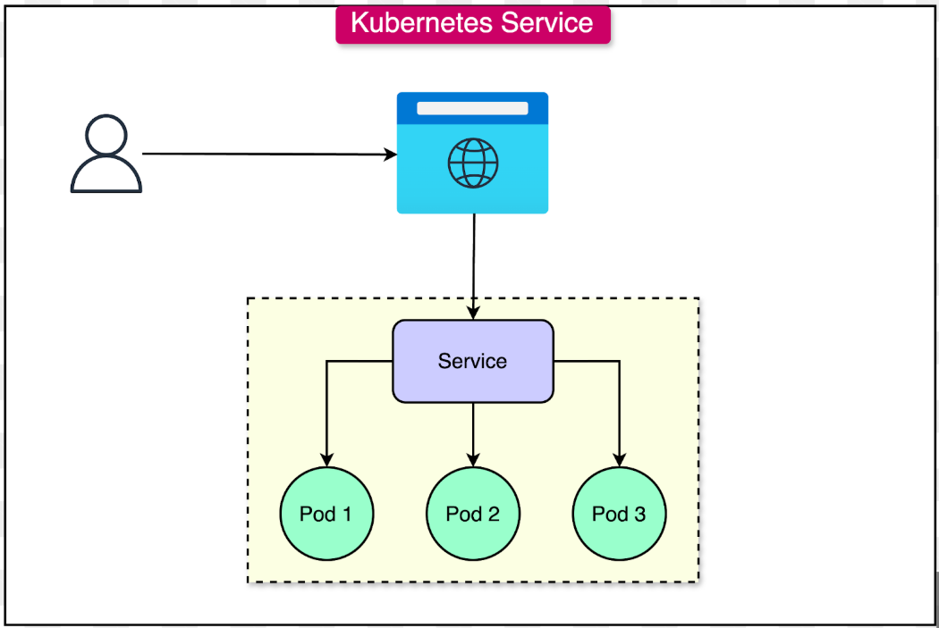

Exercise 1: Deploy a simple web application using NodePort
Objective: Deploy a web application and expose it using NodePort.
Steps:
- Create a Deployment for an Nginx web server.
- Expose the Deployment using a Service of type NodePort.
Solution:
# 1. Create the Nginx Deployment
kubectl create deployment nginx --image=nginx

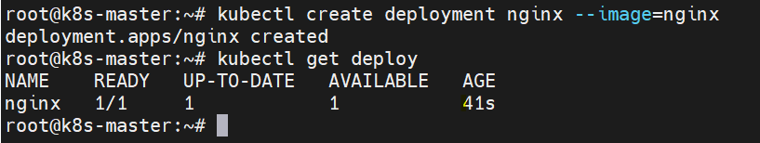

# 2. Expose the Deployment using a NodePort Service
kubectl expose deployment nginx --type=NodePort --port=80

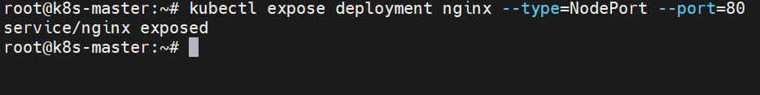

Exercise 2: Access the application through NodePort
Objective: Access the web application exposed in Exercise 1 from outside the cluster.
Steps:
- Identify the node's IP address and the service's NodePort.
- Access the application using a web browser or curl.
Solution:
# 1. Get the NodePort assigned to the service
NODE_PORT=$(kubectl get svc/nginx -o=jsonpath='{.spec.ports[0].nodePort}')

# 2. Get the node's IP address (this might depend on the environment)
NODE_IP=$(kubectl get nodes -o=jsonpath='{.items[0].status.addresses[?(@.type=="ExternalIP")].address}')
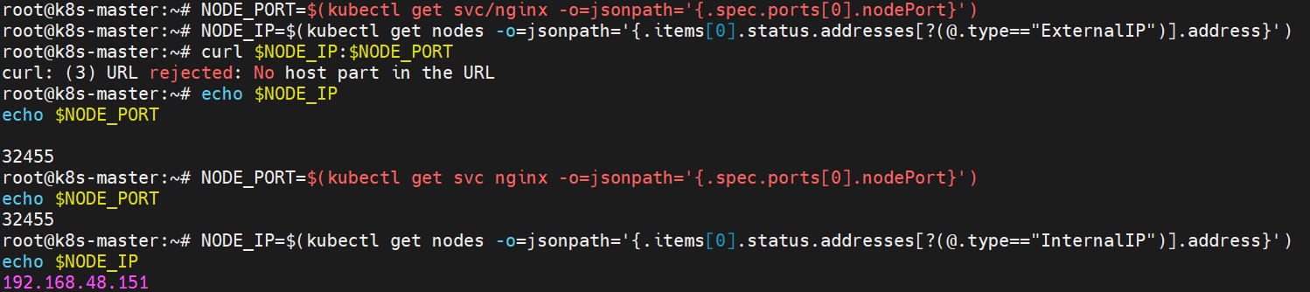

# 3. Access the web application (using curl for this example)
curl $NODE_IP:$NODE_PORT
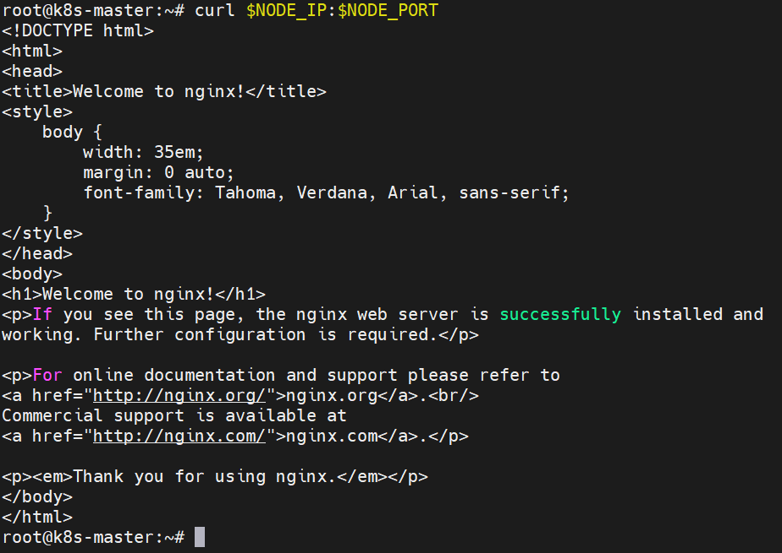

Exercise 3: Set a specific NodePort for a service
Objective: Deploy a web application and set a specific NodePort for the service.
Steps:
- Deploy another version of Nginx.
- Create a Service definition YAML with a specified NodePort.
Solution:
# nginx-nodeport.yaml
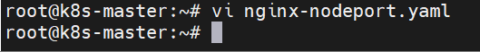
apiVersion: v1
kind: Service
metadata:
name: nginx-fixed-port
spec:
type: NodePort
ports:
- port: 80
nodePort: 30007
selector:
app: nginx
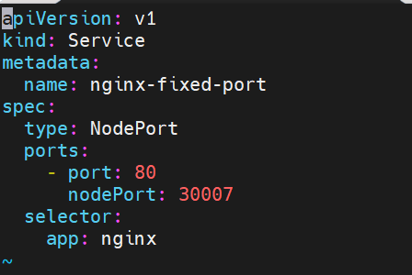
# Apply the service definition
kubectl apply -f nginx-nodeport.yaml

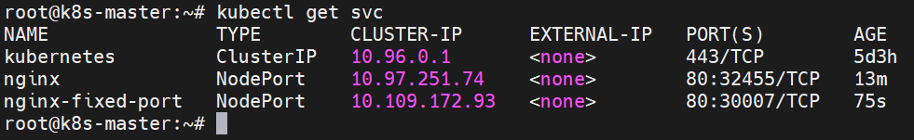

Exercise 4: Change the NodePort of an existing service
Objective: Update an existing NodePort Service to use a different port.
Steps:
- Edit the existing NodePort Service.
- Change the NodePort to a different value.
Solution:
# Edit the service directly using kubectl
kubectl edit svc/nginx-fixed-port
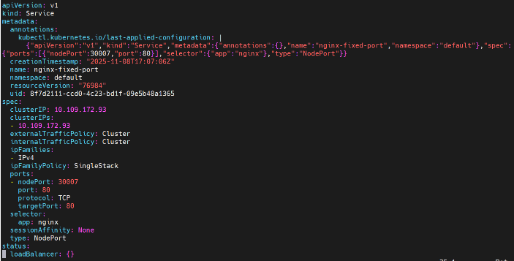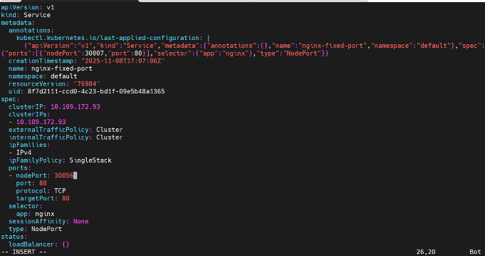

# Change the nodePort value under spec.ports[0].nodePort to another value (e.g., 30008)
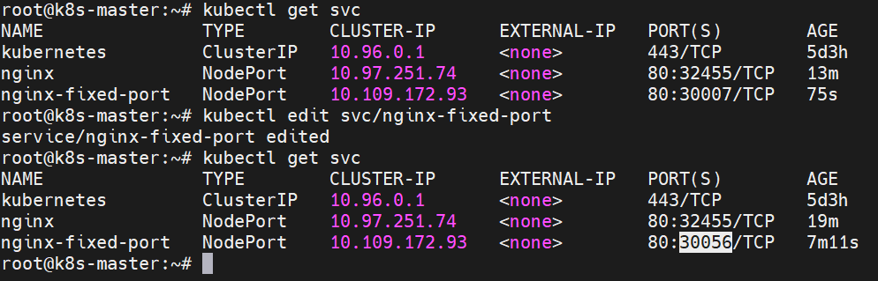

Exercise 5: Clean up resources
Objective: Delete all the resources created in the previous exercises.
Steps:
- Delete the Deployments and Services related to Nginx.
Solution:
kubectl delete deployment nginx
kubectl delete svc nginx
kubectl delete svc nginx-fixed-port

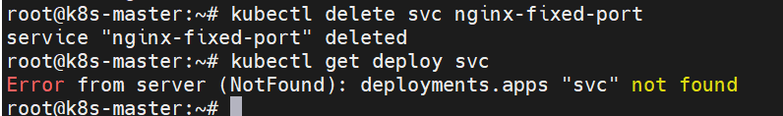

ClusterIP
The default service type, exposing the service only within the cluster. It provides a stable internal IP address for Pod-to-Pod communication.
Check api version and service name:
Kubectl api-resources | grep resource
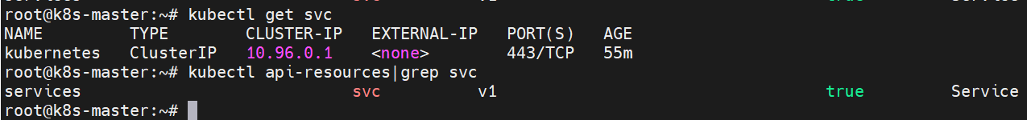Create deployment yaml file:
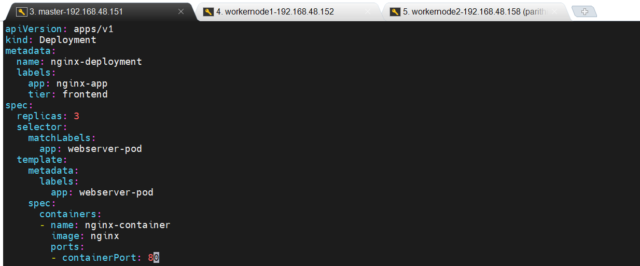
Create deployment:
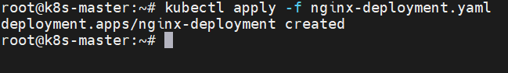

Create service yaml file:
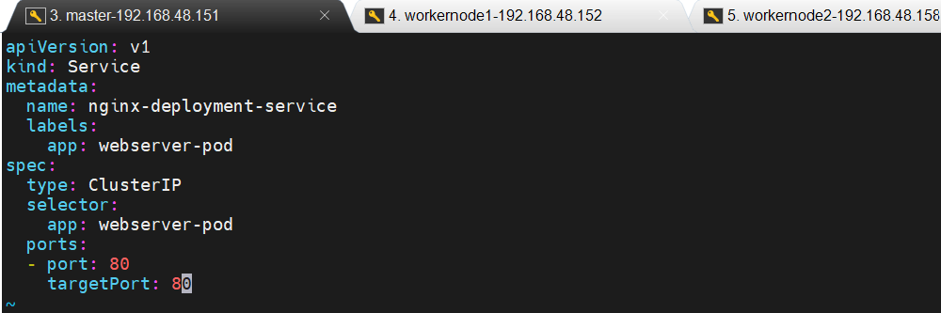
Create a Service:
View deployment, replica set, pod and service with full details:
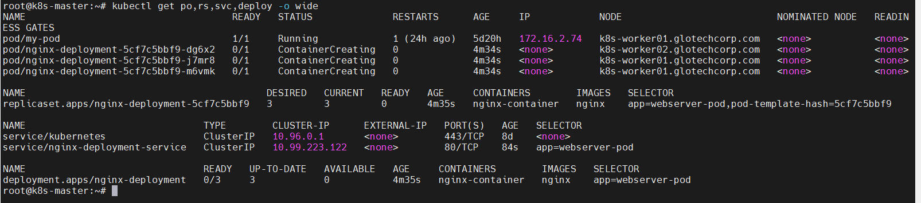
Access the webserver using curl command:
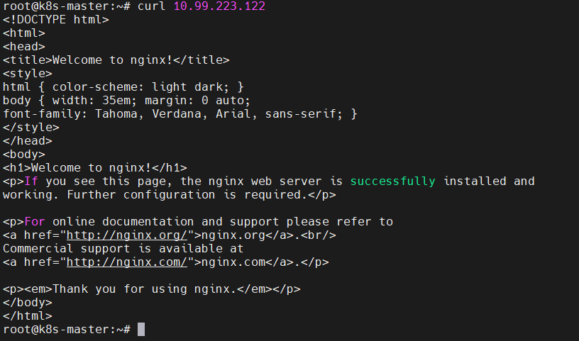

EndPoint:
An Endpoint (specifically, an Endpoints object) is a Kubernetes API object that stores the IP addresses and ports of the Pods backing a Service.
It essentially acts as a dynamic address book for a Service, allowing it to discover and route traffic to the correct Pods.
To view endpoint:
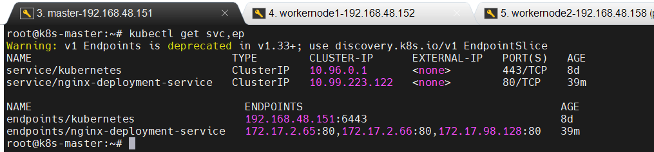
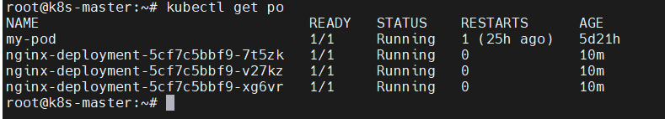
Open every deployment-pods. Provide some contents in every pod.
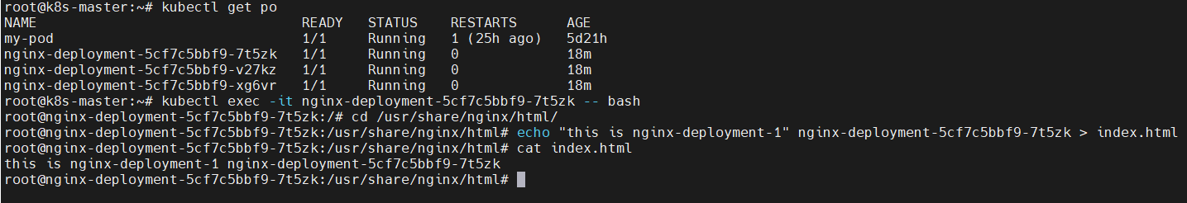
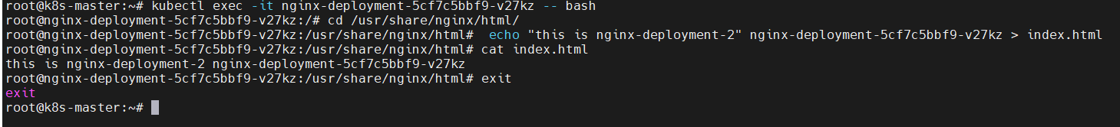
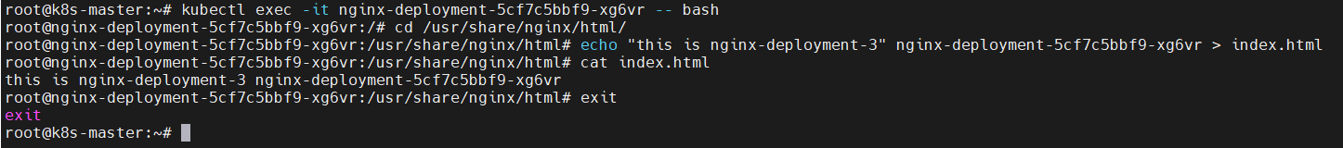
To access every pods using curl command with cluster IP.
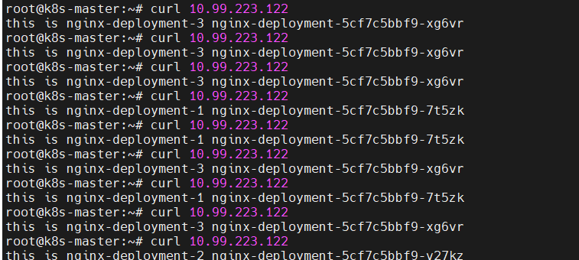
NodePort
Exposes the service on a static port on each Node in the cluster. This allows external traffic to reach the service through any Node's IP address and the specified port.
A NodePort is a Kubernetes service type that exposes an application by opening a specific port on every node in the cluster, allowing external clients to access the service using: <Node-IP>:<NodePort>
Default NodePort range:
30000 – 32767
✔ Kubernetes automatically picks a port in this range if you don’t specify
✔ If you specify manually, it must be within this range
Create nodeport yaml file:
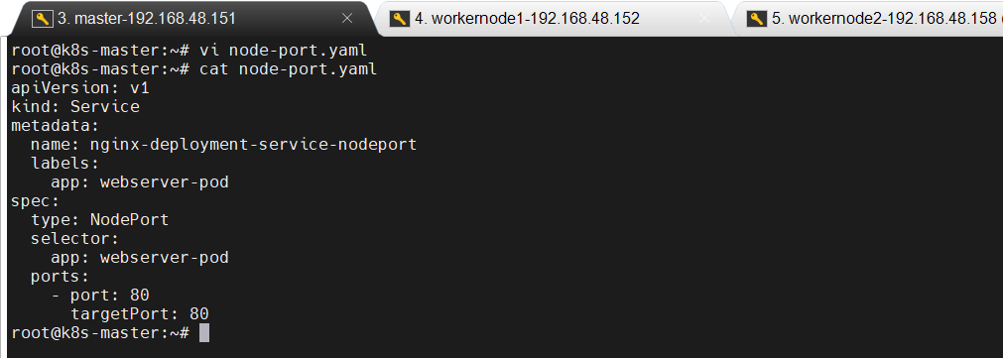
Create a NodePort:
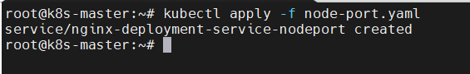
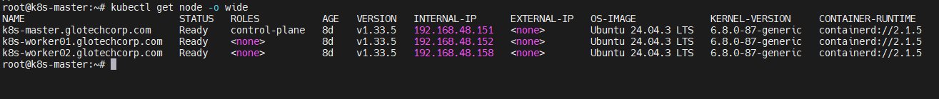
#curl <any_node_IP>:<node_port>
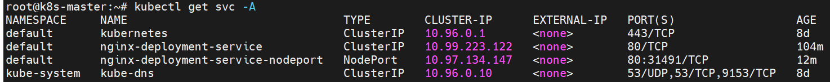
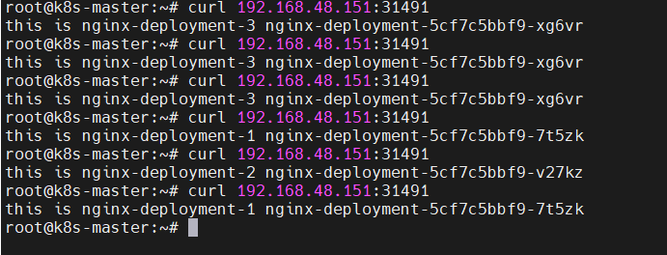

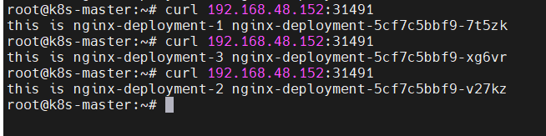

LoadBalancer

LoadBalancer = A service that gets a public IP and load-balances traffic to your pods.
Exposes the service externally using a cloud provider's load balancer. This type is typically used in cloud environments to distribute external traffic across the service's Pods.

Create a Load Balancer yaml file:\

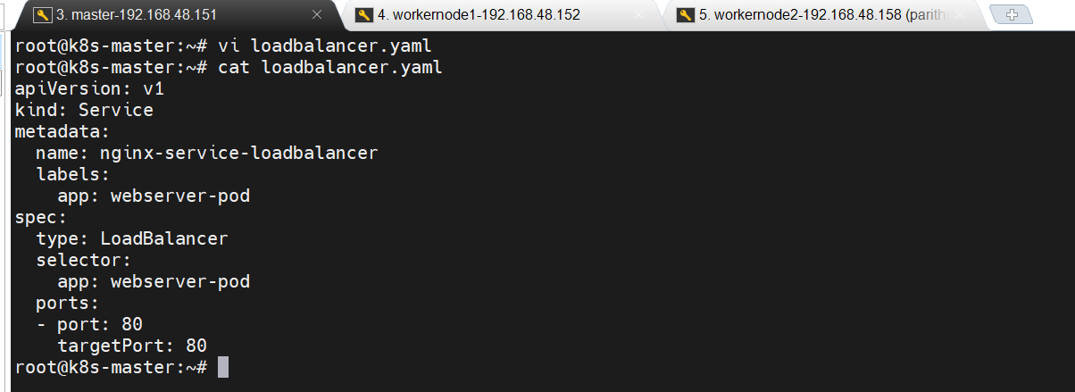

Create a LoadBalancer:

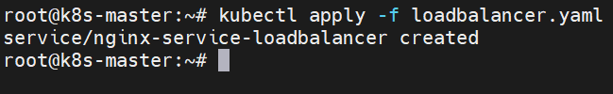

Load Balancer doesn’t contain External IP address.
If you want external IP, install metal LB.

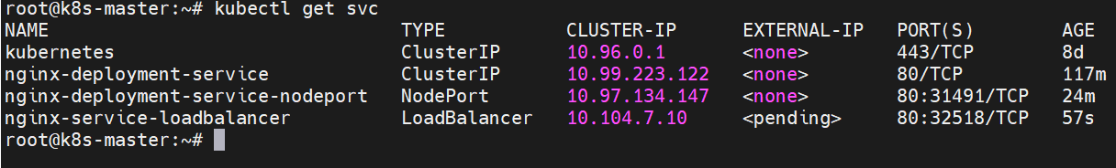

In metal LB browser:
Installation-> copy code in installation by menifest.
Copy the apply code and paste it.
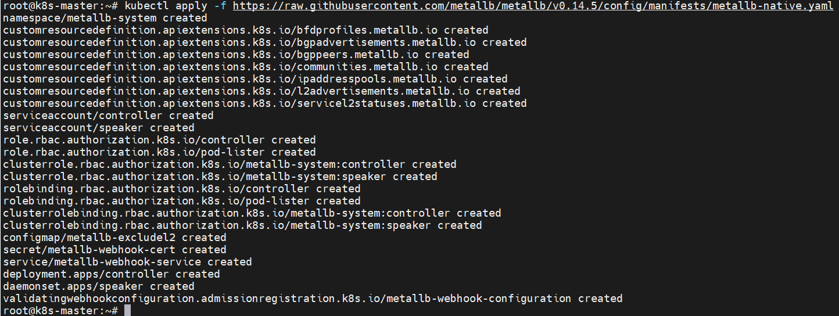

In metla LB website->Go to configuration -> Layer 2-> copy first coding and paste it in yaml file.
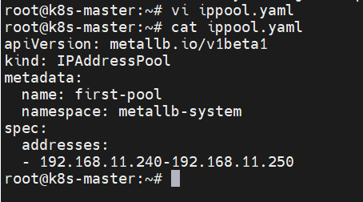

Then copy second coding and paste it another yaml file.
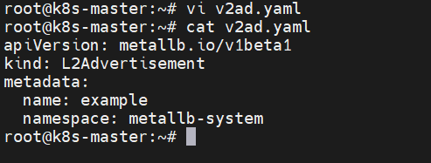

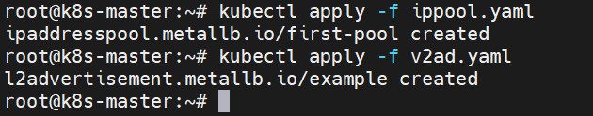
Delete the old Load Balancer.

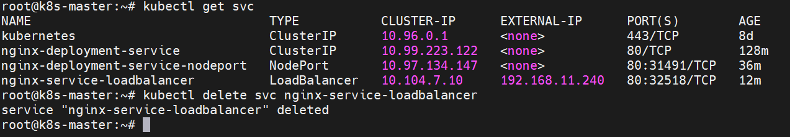

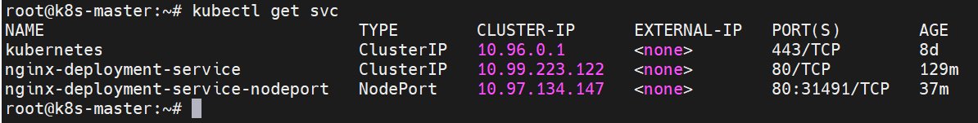

Create a new Load Balancer:
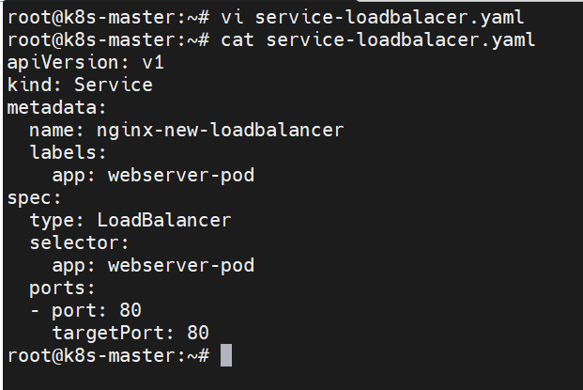

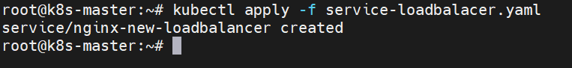

Load Balancer contain external IP to distribute external traffic across the service's Pods.
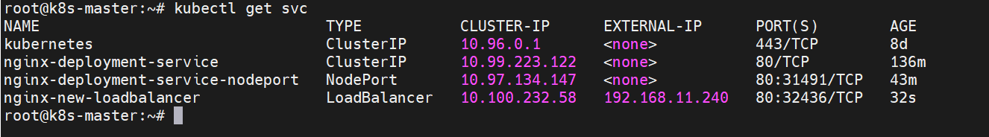

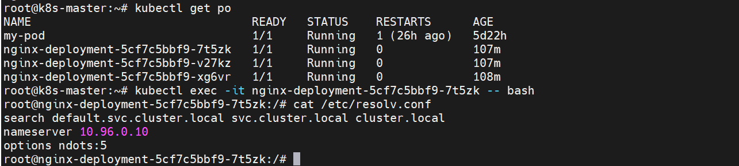

nameserver 10.96.0.10
- This is the ClusterDNS IP, managed by CoreDNS inside your Kubernetes cluster.
- It means DNS resolution inside pods is working through the Kubernetes internal DNS service.
- Any service like nginx-service.default.svc.cluster.local will be resolved by CoreDNS via that IP.

To access the application via service with curl command:

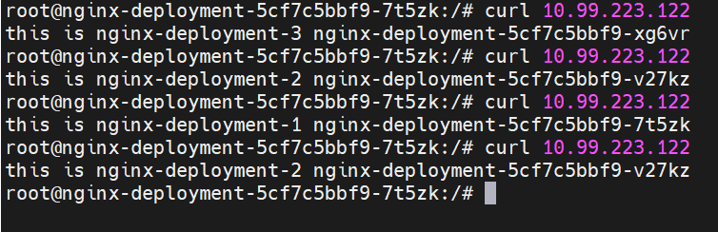

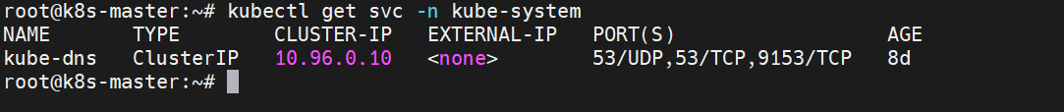

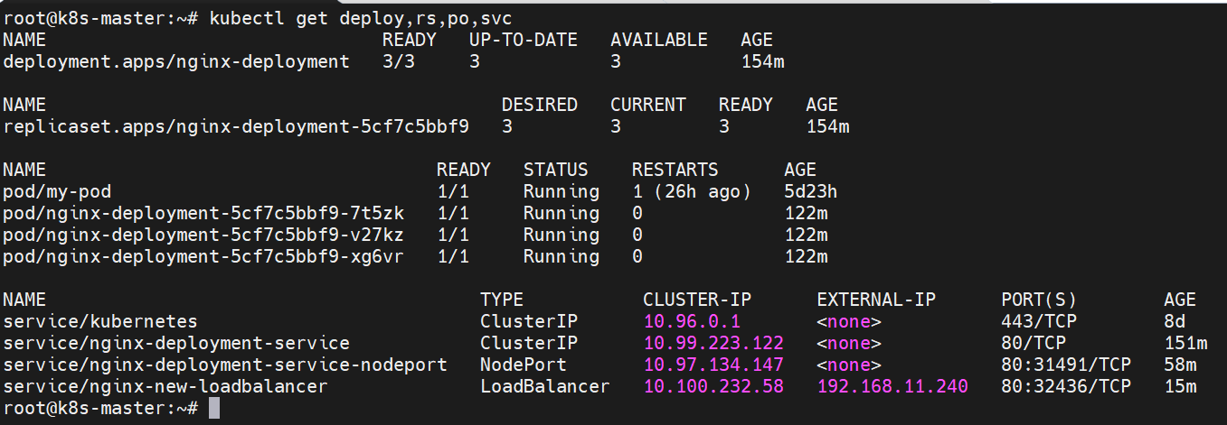

This command creates a Service named nginx-deploy-loadbalancer of type LoadBalancer that exposes your existing nginx-deployment pods.

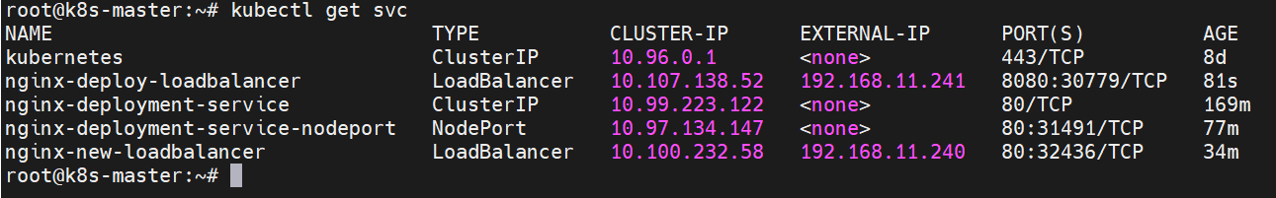

Access the webserver using cluster ip or external ip with service port.
